Group 3- Cricbuzz

Cricbuzz is a web application for getting updates regarding cricket. It includes live scores of a match to news regarding cricket all over the world. This application is a dynamic project where the scores are updated on real time basis.

The page is divided into multiple regions having navigation bar, live scores, news, videos, photos and advertisements. This project can be achieved by using many technologies like Spring Boot, Spring Data, Hibernate, MongoDb, JSP, Spring rest and so on.

We have divided the project into many milestones having various stories in it. By doing this, we can calculate the average time taken and testing can be done easily.

# Milestone 1: Navigation Bar

The navigation bar contains various elements like LOGO, Teams, Series and Ranking. On selecting any of these options their respective pages are loaded.

## Stories:

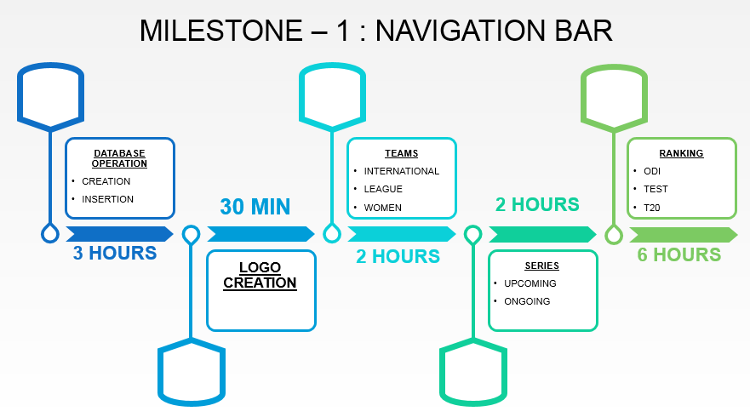

1. **Database Operation**: Creation of database collection and insertion of documents into it using MongoDB.

**Average time for completion** – 3 hours.

* Collection Name - ODI, Test, T20, Teams, Series, International, League, Women.

1. **Logo Creation:** In this story when the end user or client clicks on the cricbuzz logo it will redirect to the home page irrespective of the page the user is in.

**Average time for completion** – 30 minutes.

1. **Teams**: On selecting this tab, it takes us to a new page where we get the options like International, League, and Women team. On selecting one of the option the user is able to view the respective list of countries/clubs that are active in cricket.

**Average time for completion** – 2 hours.

1. **Series**: This tab takes us to the page which contains the ongoing as well as the upcoming series. It contains details of the team as well as the schedule of the series. For Example: India tour of England, 2018.

**Average time for completion** – 2 hours.

1. **Ranking**: This tab leads to the ranking page. It consists of top 10 players from around the world in the fields of batting, bowling, all-rounder and teams based on ODI, Test and T20 format of the game. When the user wants to know the top batsmen in tests he has to select the option test and then batsman to get the list of the top 10 batsmen same thing applies for all other options. The data is retrieved from the database using queries.

**Average time for completion** – 6 hours.